Online Electronics Retail Store E-Business System
User Documentation
Prepared for COIT20259 Enterprise Computing Architecture Assignment 2

Contents
1. Introduction 3
2. System Requirements 4
3. Compiling and Deploying the System 4
4. User Registration, Login, Logout, and Account Recovery 11
5. Product Management 19
6. Customer Management 28
7. Order Management 33
8. Conclusion 40

1. Introduction

This document provides user instructions on how to compile, install and operate the e-business system of the Online Electronics Retail Store, which has been produced for COIT20259 Enterprise Computing Architecture Assignment 2. The system is a Jakarta EE 3-tier business web application that registered users use to handle electronic products, customers and orders. The manual shows how to deploy the application, register and login, recover an account and utilize the system to persist tablet, smartwatch, customer and order details.

2. System Requirements

Before compiling and deploying the application, the following software and tools are required:

• NetBeans IDE
• JDK compatible with the Jakarta EE project
• GlassFish Server
• MySQL Server
• MySQL database for storing application data
• FakeSMTP or CentreMail for receiving verification and recovery emails
• A web browser such as Google Chrome or Microsoft Edge

3. Compiling and Deploying the System

This section explains how to compile and deploy the Online Electronics Retail Store e-business system. The system was developed as a Jakarta EE web application using NetBeans IDE, GlassFish Server, and MySQL database.

3.1 Required Software

Before deploying the application, ensure that the following software is installed and configured:

• NetBeans IDE
• JDK compatible with GlassFish and Jakarta EE
• GlassFish Server
• MySQL Server
• MySQL Connector/J driver
• FakeSMTP or CentreMail for testing verification and recovery emails
• Web browser, such as Google Chrome or Microsoft Edge

3.2 Starting MySQL Server

1. Start the MySQL Server on the local computer.
2. Open MySQL Workbench or another MySQL management tool.
3. Confirm that the MySQL server is running.
4. Ensure that the database used by the application exists.
5. Confirm that the database username and password match the database connection settings used in the project.

If the database does not exist, create it before deploying the application.

Example database name:

ebusiness_db

3.3 Opening the Project in NetBeans

1. Open NetBeans IDE.
2. Select File > Open Project.
3. Browse to the folder containing the project.
4. Select the project folder and click Open Project.
5. Wait for NetBeans to load the project files.
6. Check that the project contains the required Java source files, persistence configuration files, and Jakarta XHTML pages.

Figure 1: NetBeans project opened
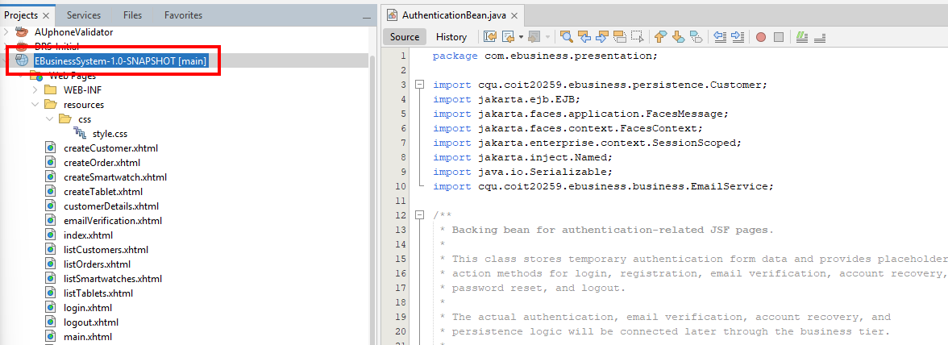

3.4 Configuring GlassFish Server in NetBeans

1. In NetBeans, go to Tools > Servers.
2. Click Add Server if GlassFish has not been added yet.
3. Select GlassFish Server.
4. Browse to the GlassFish installation folder.
5. Complete the server setup wizard.
6. Confirm that GlassFish appears in the Servers list.
7. Start the GlassFish Server from NetBeans or from the GlassFish administration console.

Figure 2: GlassFish server configuration
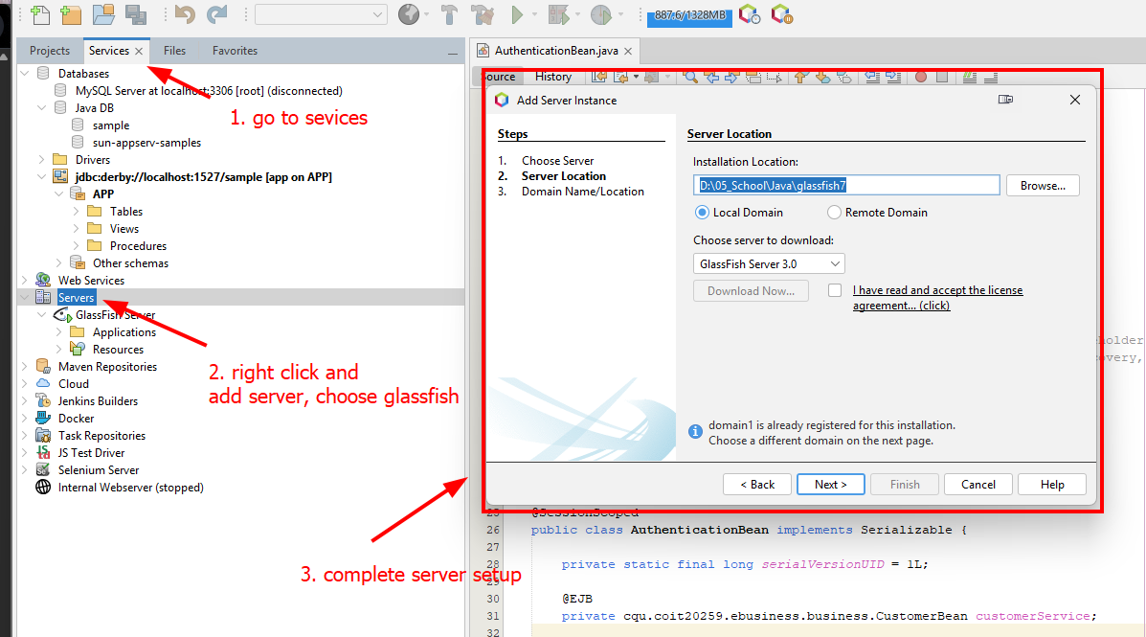

3.5 Checking the Database Connection

Before deploying the application, make sure the MySQL database connection is working.

1. Open the GlassFish Admin Console.
2. Go to Resources > JDBC > JDBC Connection Pools.
3. Select the connection pool used by the application.
4. Click Ping to test the connection.
5. If the message Ping Succeeded appears, the database connection is working.
6. Go to Resources > JDBC > JDBC Resources.
7. Confirm that the JDBC resource used by the application is available.
8. Open MySQL Workbench.
9. Connect to the MySQL server.
10. Select the ebusiness_db schema.
11. Run the following SQL command:

USE ebusiness_db;
SHOW TABLES;

12. Confirm that the application tables are displayed.

If the tables are displayed, the application is correctly connected to the MySQL database.

Figure 3. MySQL Workbench showing the ebusiness_db database tables
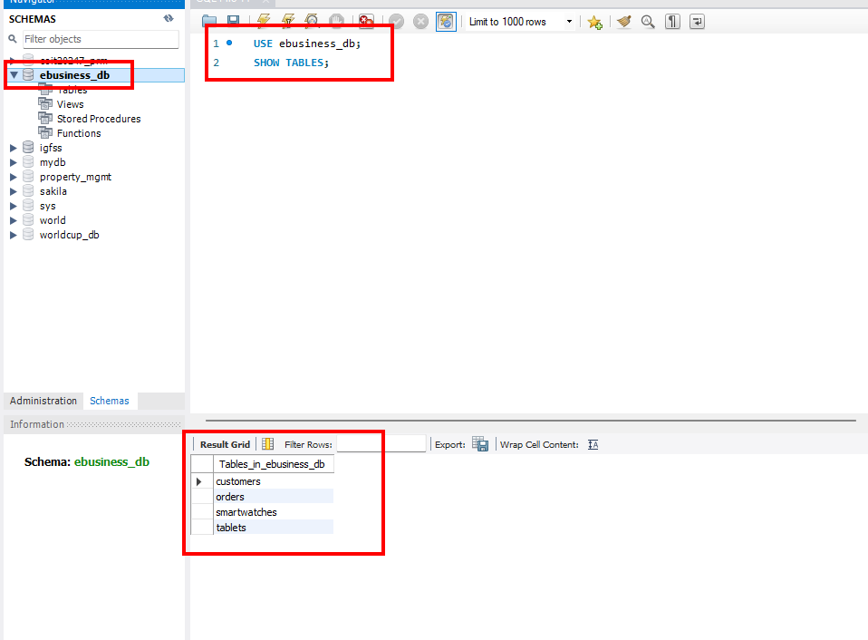

The persistence tier is required because the application stores product, customer, and order information in a MySQL database using Jakarta Persistence API.

3.6 Cleaning and Building the Project

1. In NetBeans, right-click the project name.
2. Select Clean and Build.
3. Wait for the build process to finish.
4. Check the Output window.
5. Confirm that the message BUILD SUCCESSFUL appears.
6. If the build fails, check the error message, fix the issue, and run Clean and Build again.

After a successful build, NetBeans generates the deployable application file, usually in the target or dist folder depending on the project type.

Figure 4. Build successful output
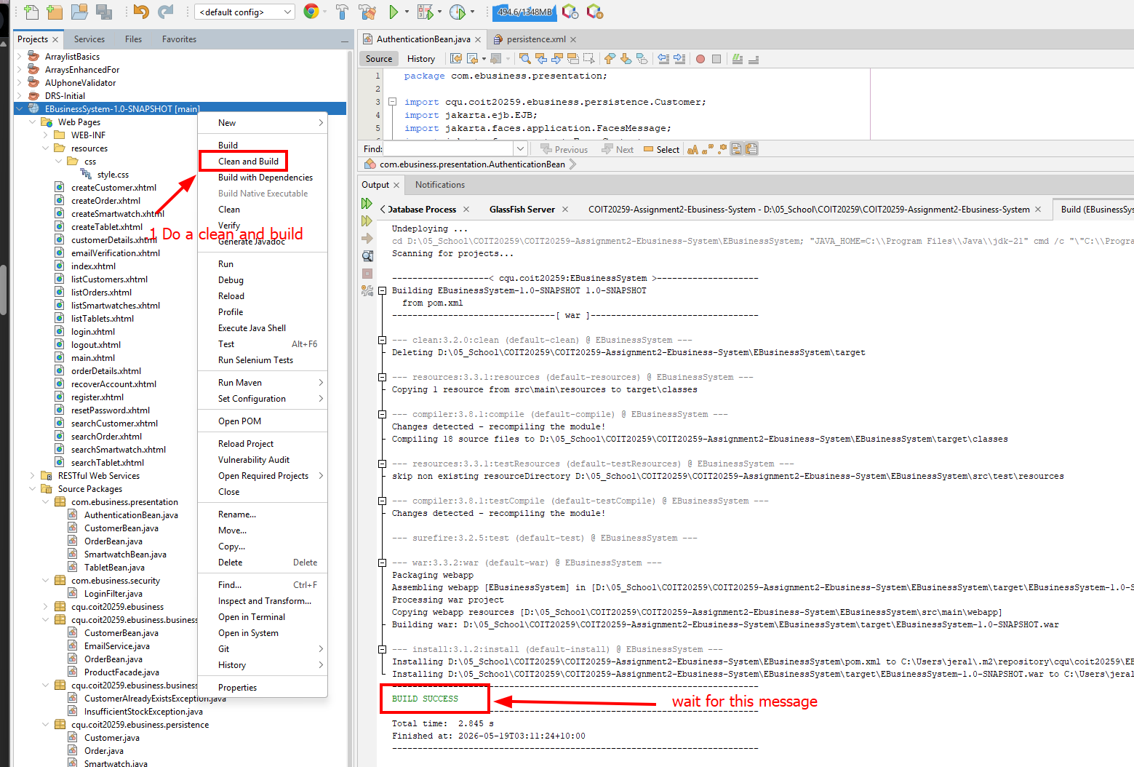

3.7 Deploying the Application to GlassFish

After the project has been cleaned and built successfully, the application can be deployed to GlassFish.

Option 1: Deploy by Running the Project in NetBeans

1. Start GlassFish Server.
2. In NetBeans, right-click the project.
3. Select Run.
4. Wait for NetBeans to build and deploy the application.
5. Check the NetBeans Output window.
6. Confirm that the application opens in the web browser.

If the application opens in the browser, the deployment was successful.

Figure 4. NetBeans Output window showing successful project deployment
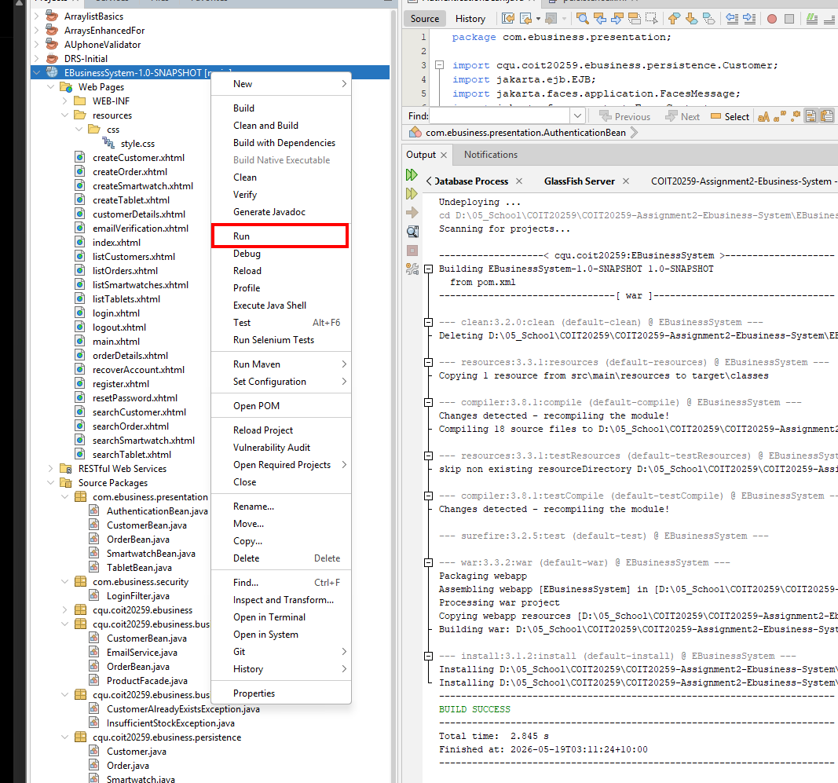

3.8 Running the Application

1. Open a web browser.
2. Enter the application URL.

http://localhost:8080/EBusinessSystem/

3. The index page should appear.
4. The user can then access the registration and login functions.
5. If a user attempts to access protected system pages without logging in, the system should redirect the user to the login page.

Figure 5. Application index page opened successfully in the web browser
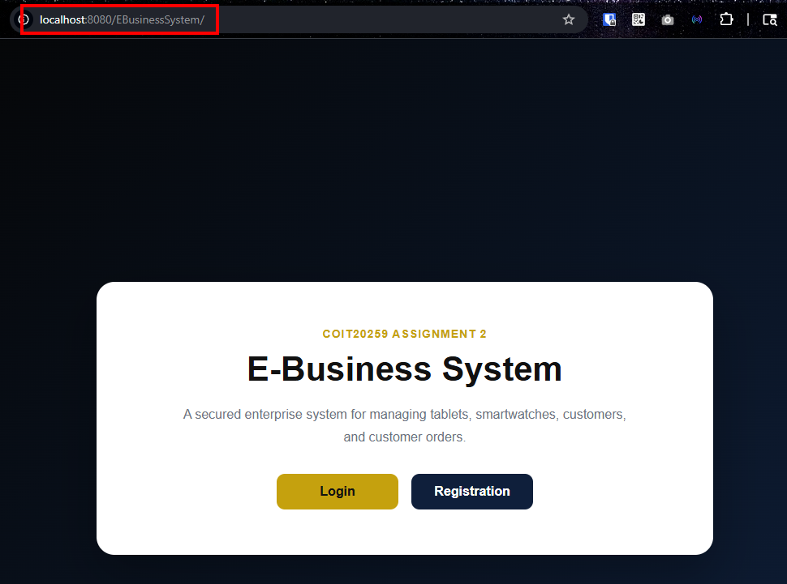

4. User Registration, Login, Logout, and Account Recovery

This section explains how to start the FakeSMTP server, register a new user, verify the user account, log in to the system, log out, and recover an account if the user forgets the username or password.

4.1 Starting FakeSMTP Server

Before registering a new user or recovering an account, start the FakeSMTP server. The system uses FakeSMTP to receive the verification code and recovery code emails.

1. Open the FakeSMTP application.
2. In the Listening port field, enter 2525.
3. Click Start server.
4. Leave FakeSMTP running while using the registration and account recovery functions.
5. When the system sends an email, check the FakeSMTP message list.
6. Click the received message to view its contents.
7. Copy the verification code or recovery code from the email.

Figure 6. FakeSMTP server configured with port 2525 before starting the server

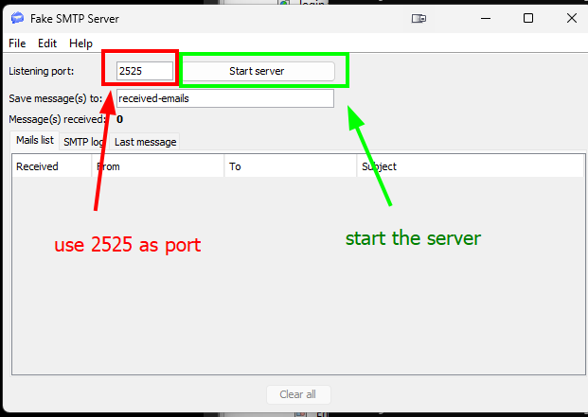

4.2 Registering a New User

To access the system functions, a user must first register an account.

1. Open the application in a web browser.
2. On the index page, go to the user registration section.
3. Enter the required user details, such as first name, last name, username, password, and email address.
4. Make sure the email address is valid.
5. Click the Register button.
6. The system will send a verification code to the email address entered.
7. Go to FakeSMTP and open the received verification email.
8. Copy the verification code from the email.

Figure 7. User registration form completed with valid user details
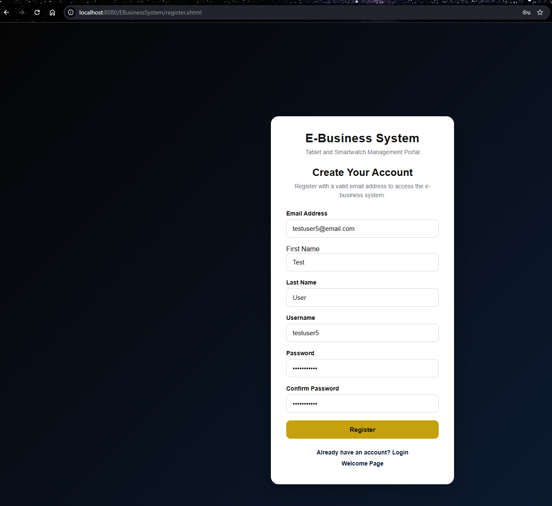

4.3 Completing Email Verification

After submitting the registration form, the user must complete email verification.

1. Open the verification page or verification section.
2. Enter the verification code received in FakeSMTP.
3. Click the Verify or Submit button.
4. Wait for the system confirmation message.
5. If the code is correct, the account registration will be completed.
6. The user can now proceed to the login page.

Figure 8. Verification code received in FakeSMTP
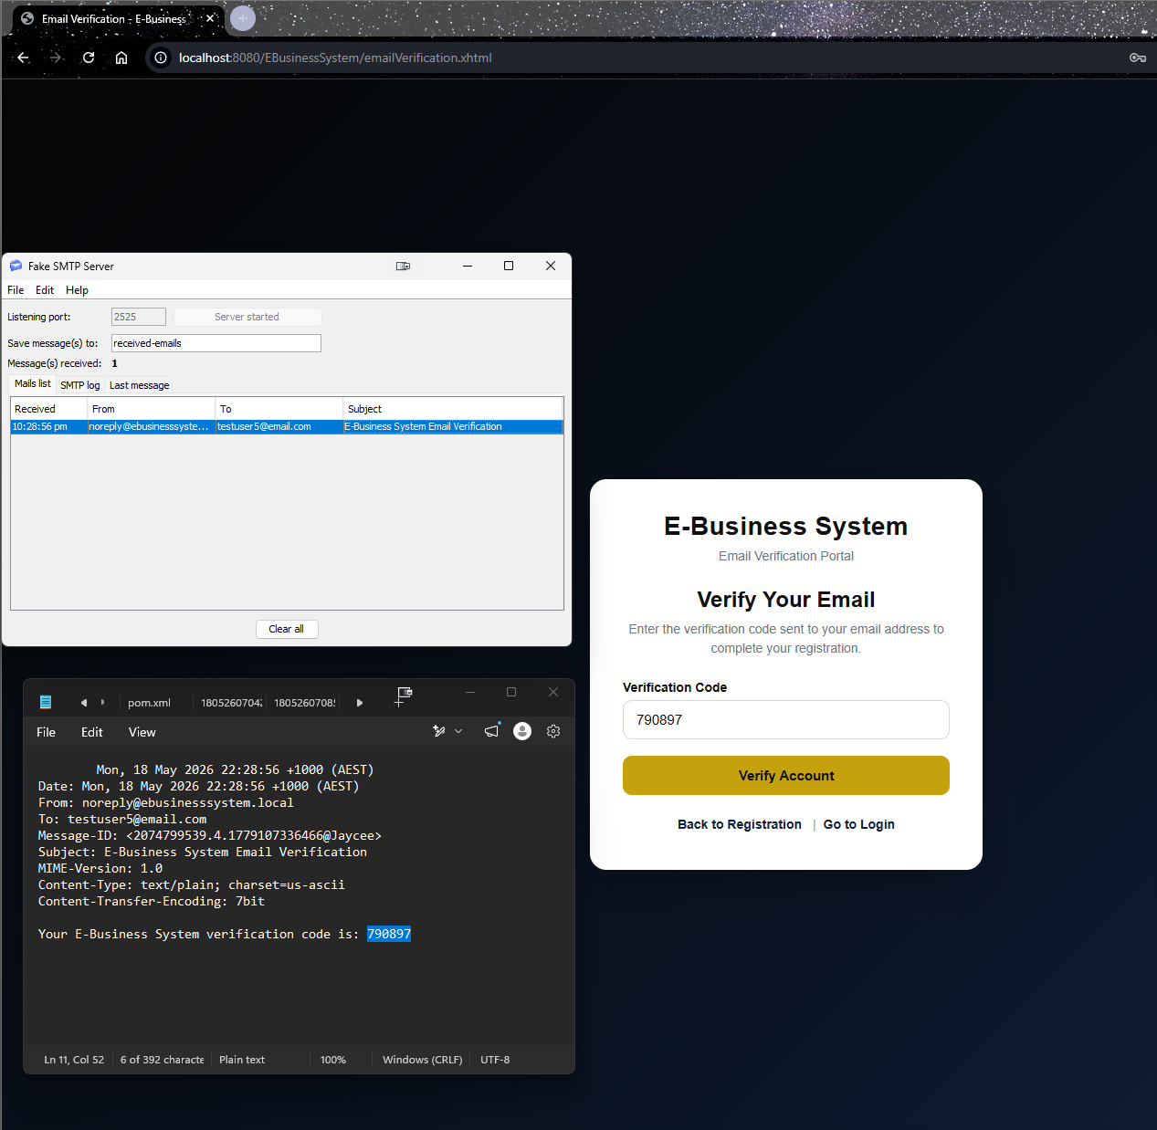

4.4 Logging In to the System

After registration and verification, the user can log in to the system.

1. Open the login page.
2. Enter the registered username.
3. Enter the registered password.
4. Click the Login button.
5. If the login details are correct, the system will open the main application page.
6. The user can now access the product, customer, and order management functions.

Figure 9. Main application page displayed after successful login
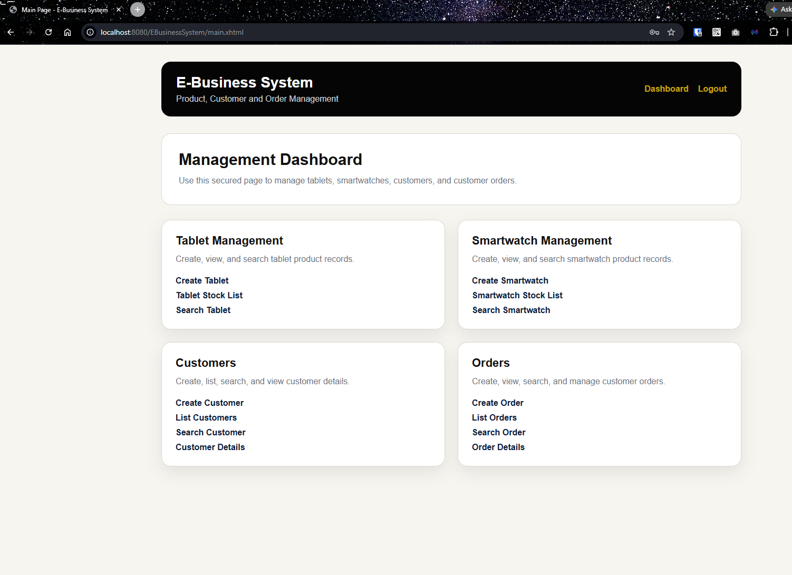

4.5 Access Protection for Non-Logged-In Users

The system protects the main function pages from users who are not logged in.

1. Open a protected system page without logging in.
2. The system should automatically redirect the user to the login page.
3. Log in using a registered account to access the protected functions.

4.6 Logging Out of the System

A logged-in user can log out after using the system.

1. Click the Logout button or link.
2. The system will end the user session.
3. The user will be redirected to the login page or index page.
4. To access the system functions again, the user must log in.

Figure 10. Login page displayed after successful logout
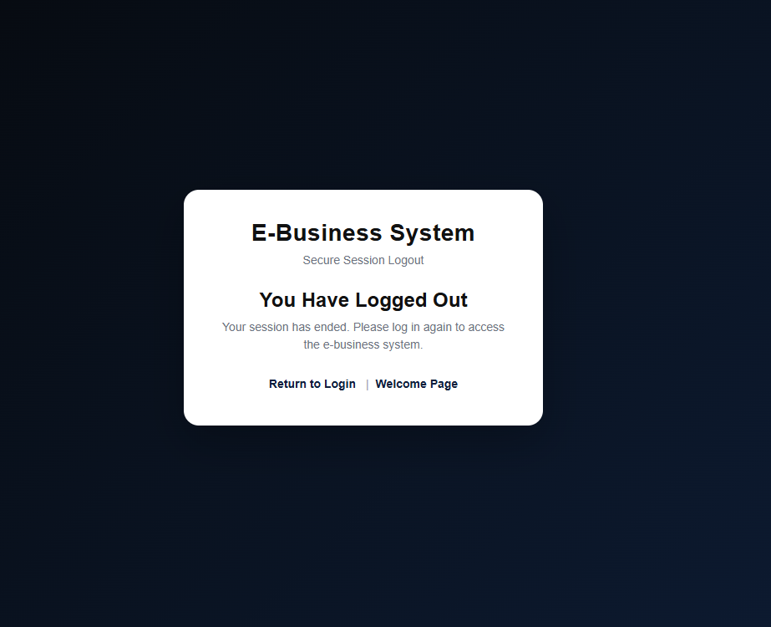

4.7 Recovering an Account

If a user forgets the username or password, the account recovery function can be used.

1. Open the account recovery page.
2. Enter the registered email address.
3. Click the Recover Account or Submit button.
4. The system will send a recovery code to the registered email address.
5. Go to FakeSMTP and open the received recovery email.
6. Copy the recovery code.
7. Enter the recovery code in the account recovery page.
8. If required, enter a new password.
9. Click Submit or Reset Password.
10. If the recovery code is correct, the system will reset the password and redirect the user to the login page.
11. Log in again using the recovered account details.

Figure 11. Account recovery form completed with registered email address
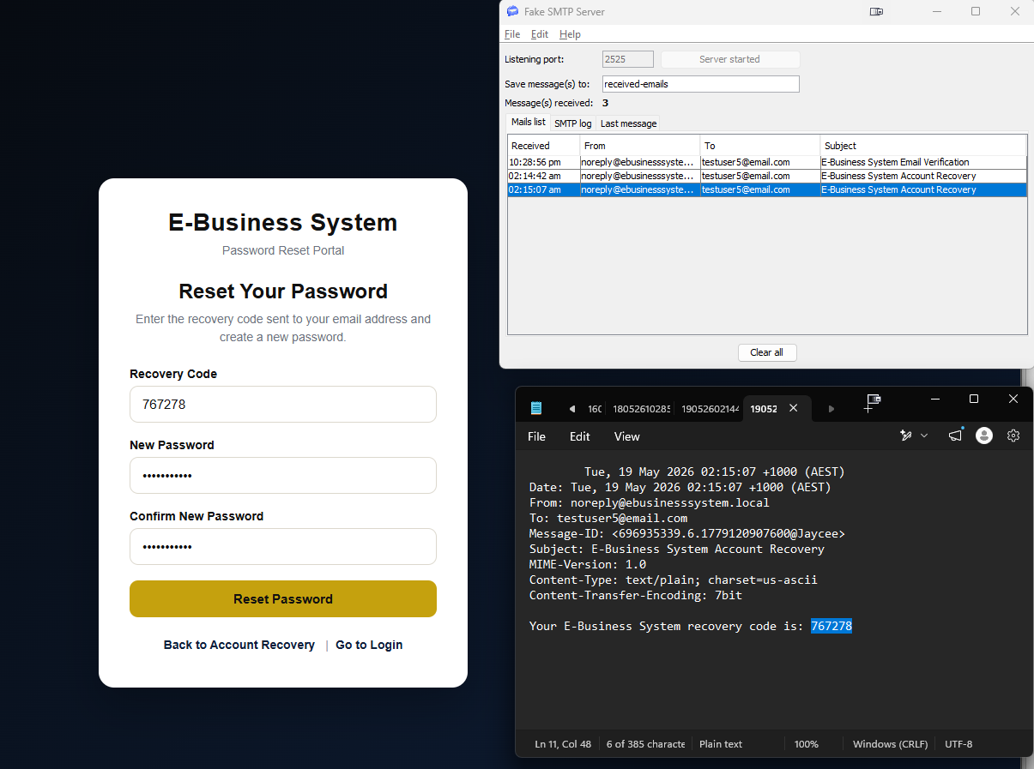

Figure 12: Useraccount password hashed
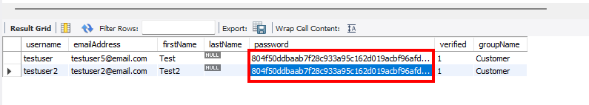

5. Product Management

This section explains how to add and view tablet and smartwatch records in the system. The application allows a logged-in user to persist product information into the MySQL database.

5.1 Adding a New Tablet

1. Log in to the system.
2. From the main page, select the option to create or add a new tablet.
3. Enter the required tablet details, such as brand, model, display size, weight, operating system, connectivity, Wi-Fi capability, storage capacity, stylus support, battery capacity, price, and stock quantity.
4. Click the Save or Create button.
5. Check that the system displays a success message.
6. Return to the tablet list or product list page.
7. Confirm that the new tablet is displayed.

Figure 13. New tablet form completed with product details
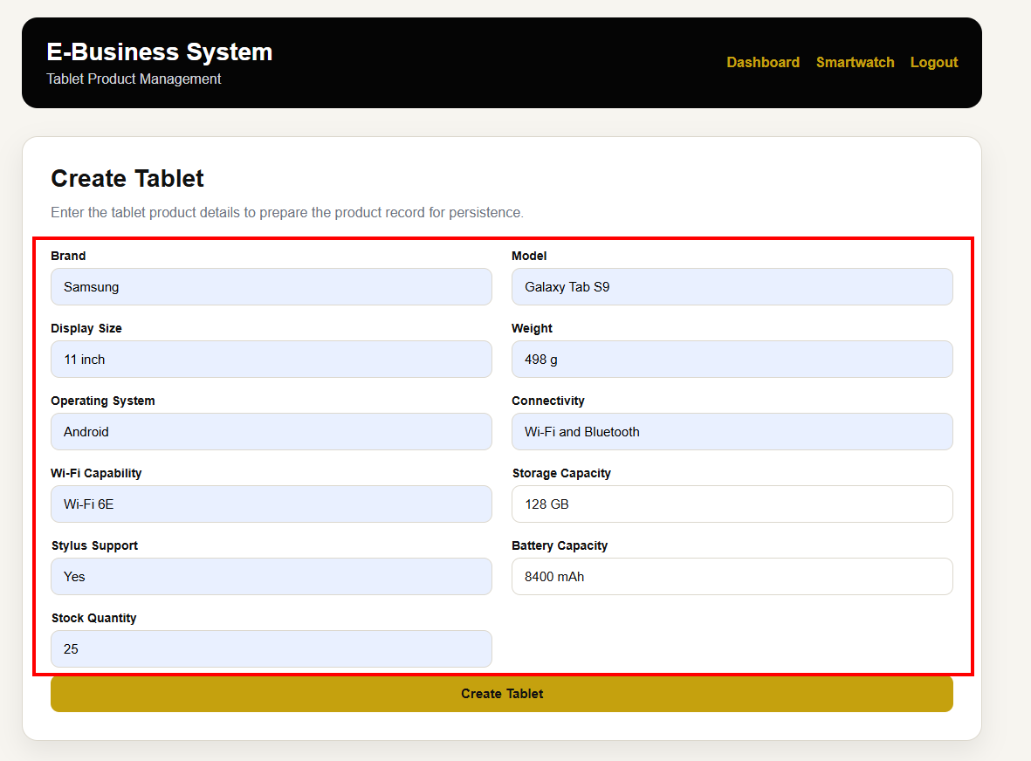

Figure 14. Tablet list showing the newly added tablet
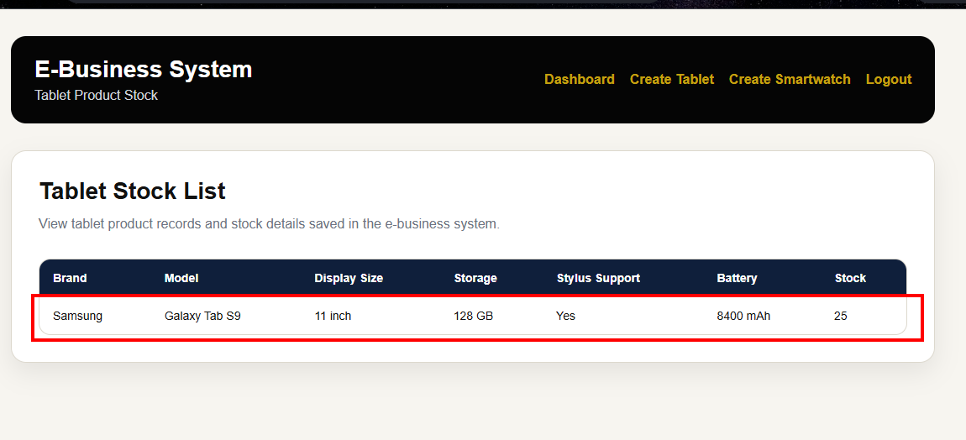

5.2 Adding a Second Tablet

1. Select the option to create or add another tablet.
2. Enter the details for the second tablet.
3. Click the Save or Create button.
4. Confirm that the system displays a success message.
5. Open the tablet list or product list page.
6. Confirm that both tablet records are displayed.

Figure 15. Second tablet added successfully
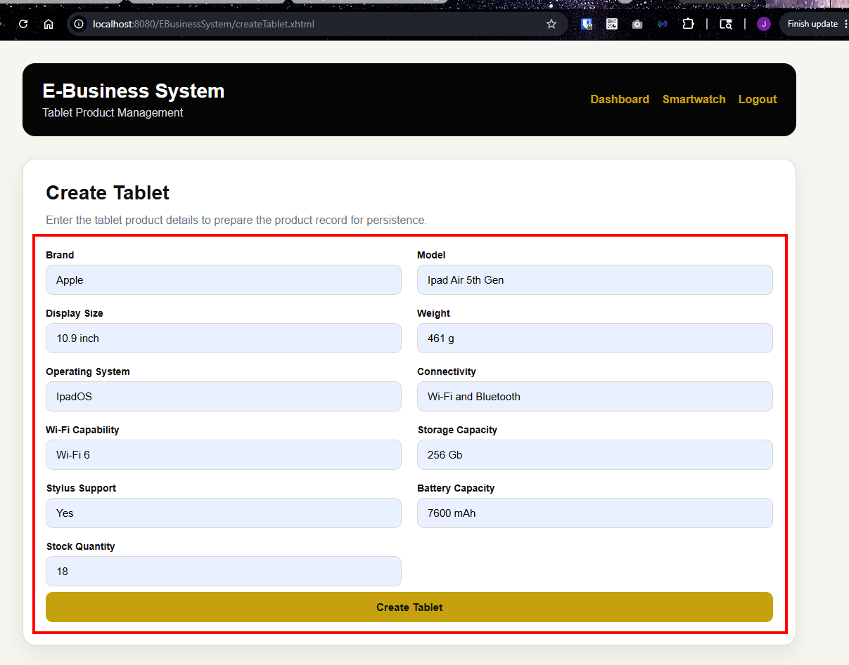

Figure 16. Tablet 2 list showing the newly added tablet
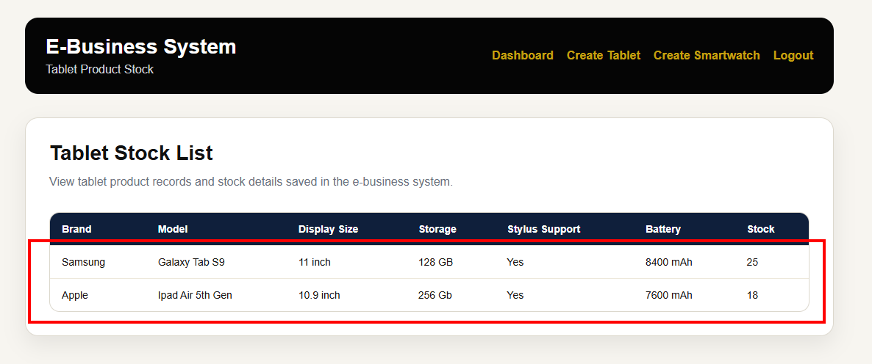

5.3 Adding a New Smartwatch

1. From the main page, select the option to create or add a new smartwatch.
2. Enter the required smartwatch details, such as brand, model, display size, weight, operating system, connectivity, Wi-Fi capability, health monitoring, fitness tracking, wearable connectivity, price, and stock quantity.
3. Click the Save or Create button.
4. Check that the system displays a success message.
5. Return to the smartwatch list or product list page.
6. Confirm that the new smartwatch is displayed.

Figure 17. New smartwatch form completed with product details
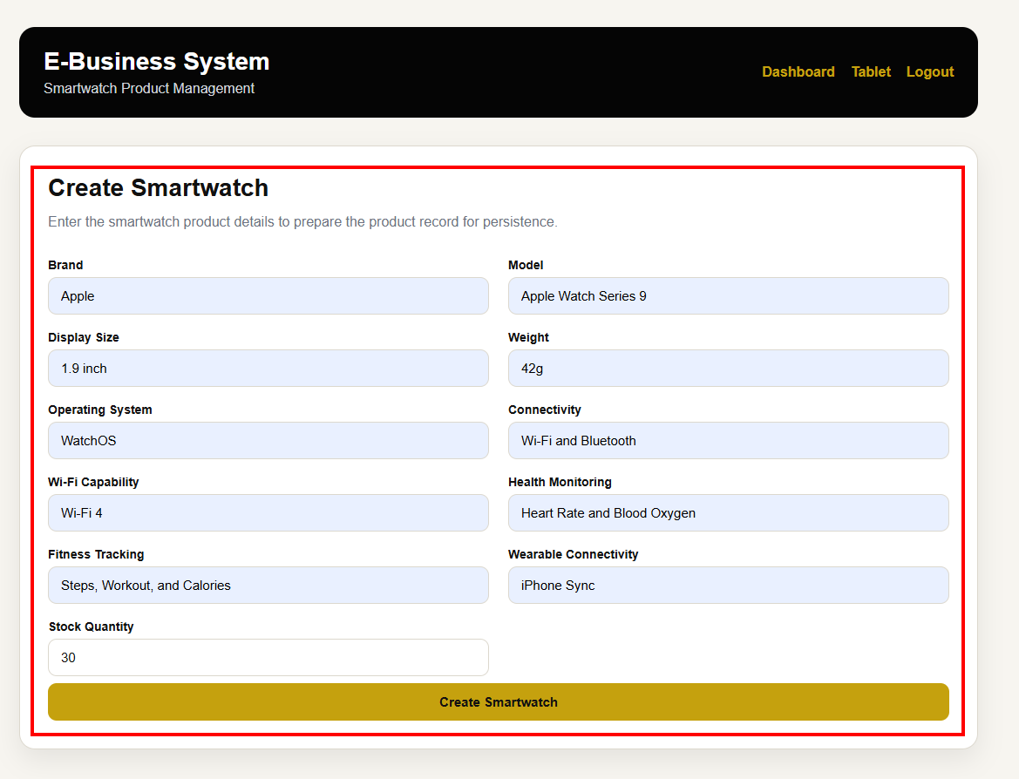

Figure 18. Smartwatch list showing the newly added smartwatch
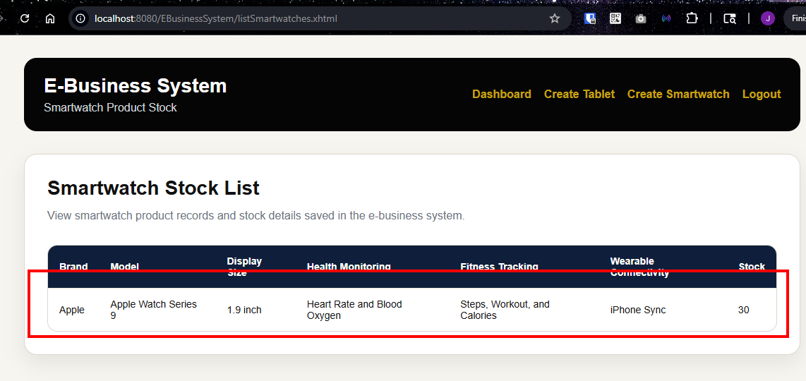

5.4 Adding a Second Smartwatch

1. Select the option to create or add another smartwatch.
2. Enter the details for the second smartwatch.
3. Click the Save or Create button.
4. Confirm that the system displays a success message.
5. Open the smartwatch list or product list page.
6. Confirm that both smartwatch records are displayed.

Figure 19. Second smartwatch added successfully
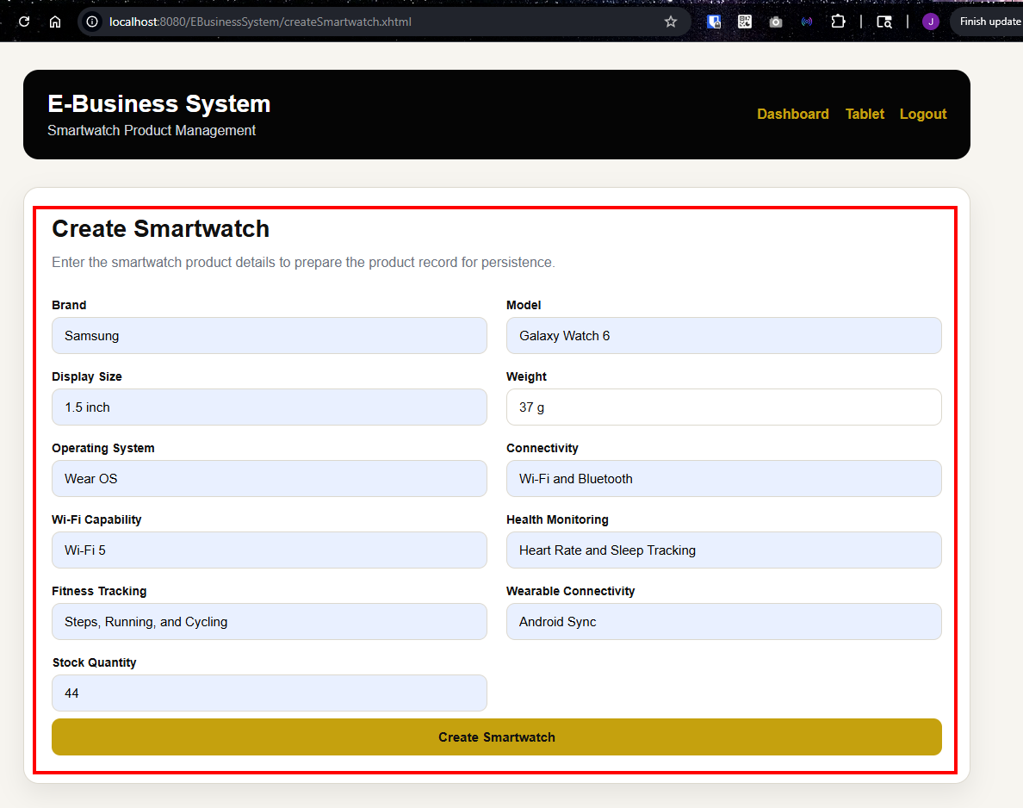

Figure 20. Smartwatch 2 list showing the newly added smartwatch
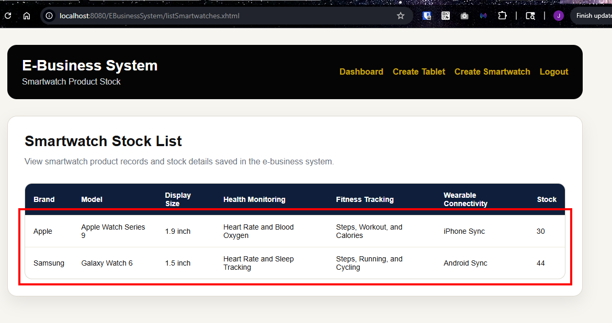

5.5 Product Management Checklist

After completing this section, confirm that:

• Two tablet records have been added.
• Two smartwatch records have been added.
• The saved products are displayed in the product list.
• Product details are stored in the database.
• Product records can be viewed again after saving.

6. Customer Management

This section explains how a logged-in user can create and view customer records in the e-business system. The assignment requires at least two customers to be saved in the system before creating orders.

6.1 Adding the First Customer

1. Log in to the system.
2. From the main page, go to the Customer Management section.
3. Click Create Customer or Add Customer.
4. Enter the required customer details.
5. Click Save or Create.
6. Check that the system displays a success message.
7. Open the customer list page.
8. Confirm that the first customer record is displayed.

Figure 20. Customer creation form completed with the first customer details
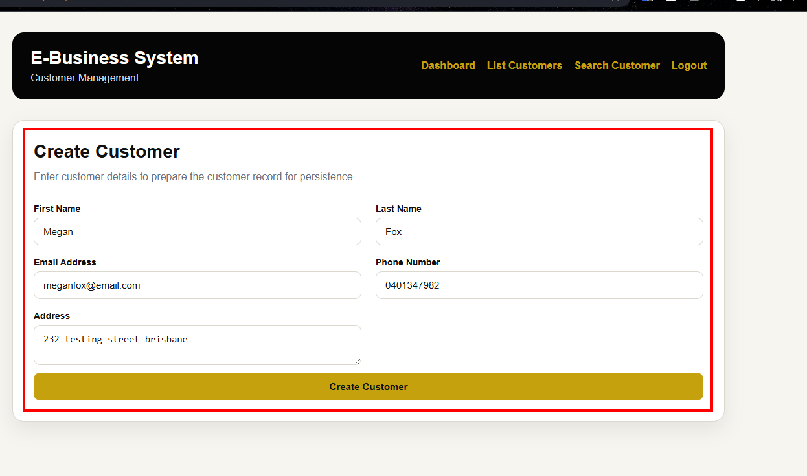

Figure 21. Customer list showing the first saved customer record
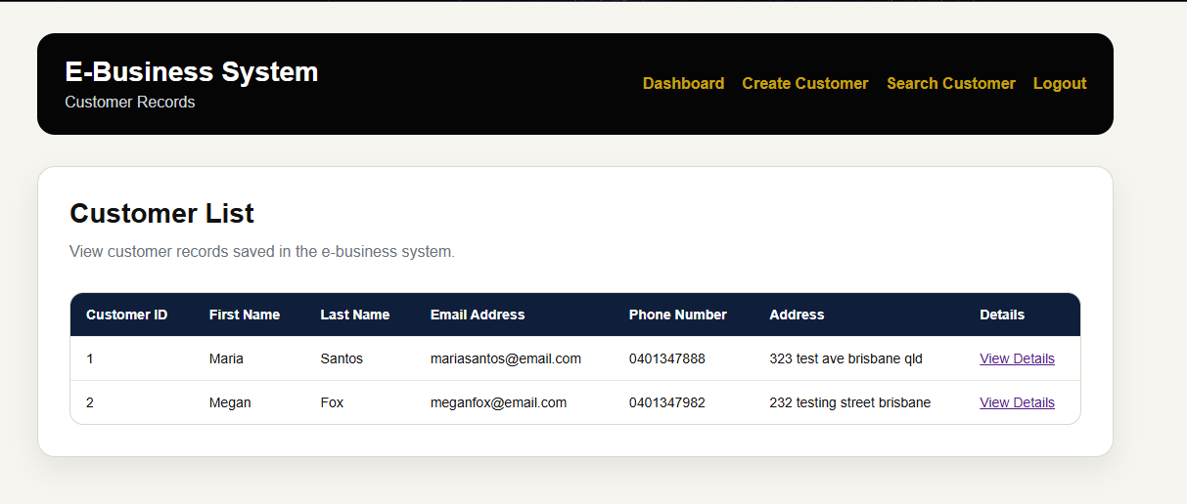

6.2 Adding the Second Customer

1. From the customer list or main page, click Create Customer or Add Customer again.
2. Enter the details for the second customer.
3. Click Save or Create.
4. Check that the system displays a success message.
5. Open the customer list page.
6. Confirm that both customer records are displayed.

Figure 22. Customer creation form completed with the second customer details

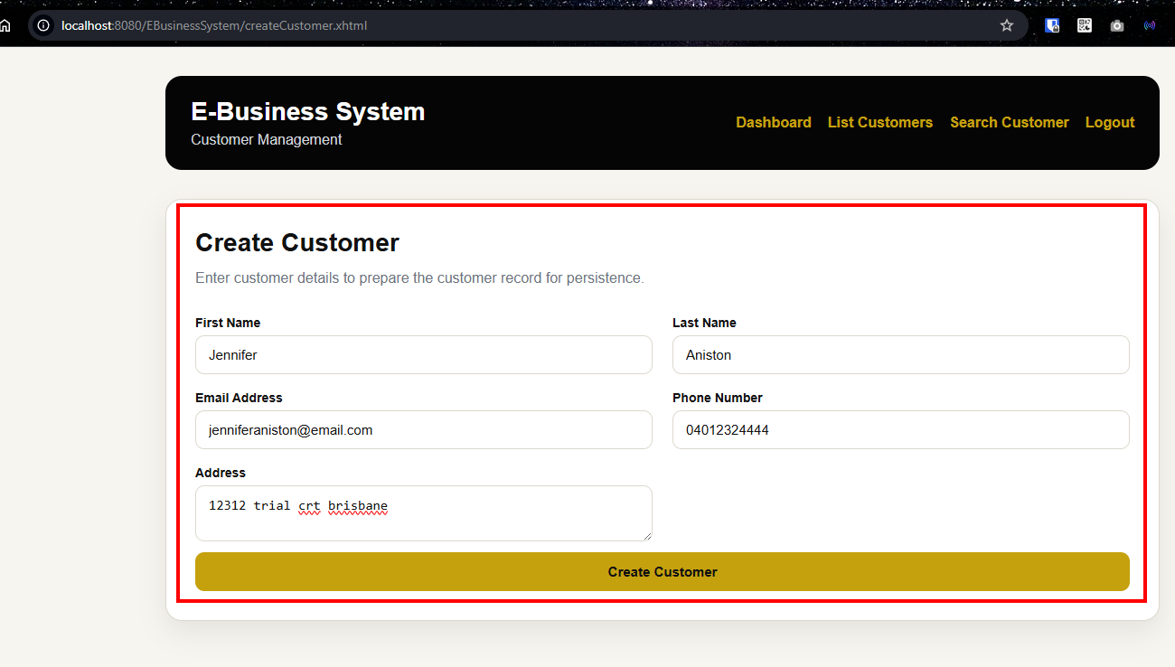

Figure 23. Customer list showing both saved customer records
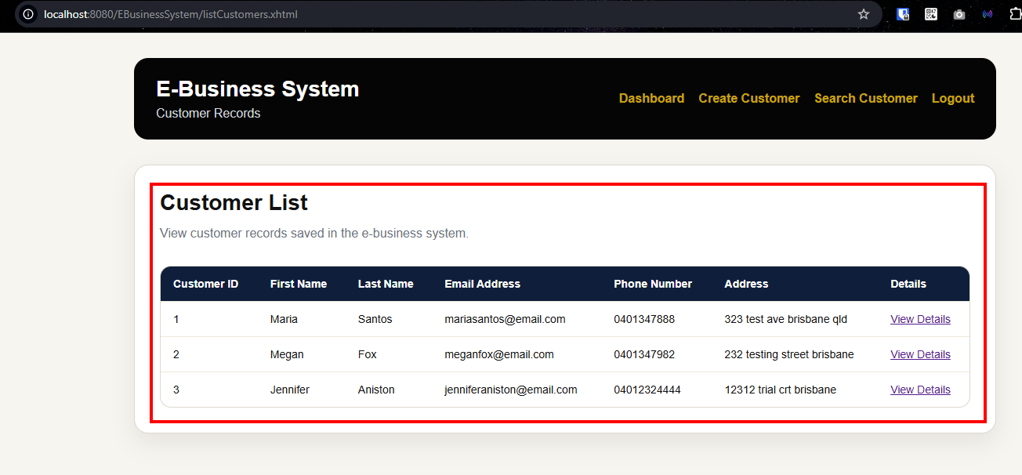

6.3 Viewing Customer Records

1. From the main page, go to the Customer Management section.
2. Click Customer List Customers.
3. Check that the saved customers are displayed.
4. Review the customer details shown in the table or list.

Figure 24. Customer list page displaying saved customer records
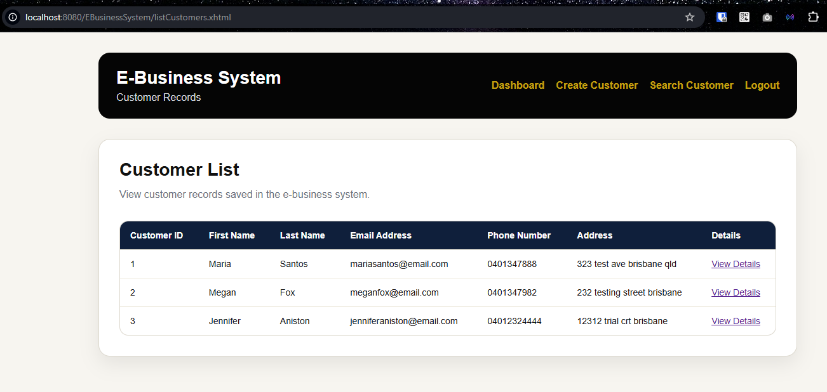

6.4 Checking Customer Records in MySQL

To confirm that the customer records were saved in the database:

1. Open MySQL Workbench.
2. Connect to the MySQL server.
3. Select the ebusiness_db database.
4. Run the following SQL command:

USE ebusiness_db;
SELECT * FROM customers;

5. Confirm that the saved customer records are displayed.

Figure 25. MySQL Workbench showing saved customer records in the customers table
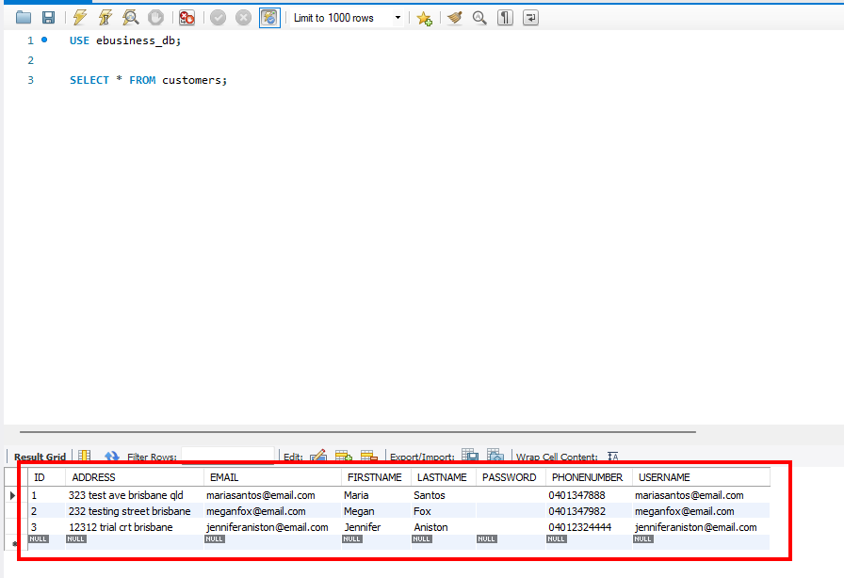

7. Order Management

This section explains how a logged-in user can create and view order records in the e-business system. The assignment requires each customer to place at least two orders: one order for a tablet and one order for a smartwatch.

7.1 Creating the Tablet Order for the Customer

1. Log in to the system.
2. From the main page, select the option to create or add an order.
3. Select the first customer from the customer list.
4. Select a tablet product.
5. Enter the order quantity and any other required order details.
6. Click Save or Create.
7. Check that the system displays a success message.
8. Open the order list page.
9. Confirm that the order record is displayed.

Figure 26. Tablet Stock List Before Order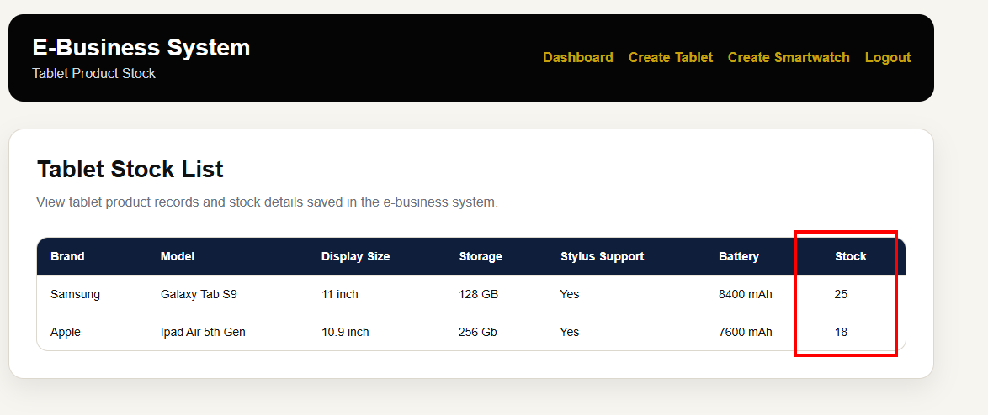

Figure 27. Order creation form completed for the first customer tablet order
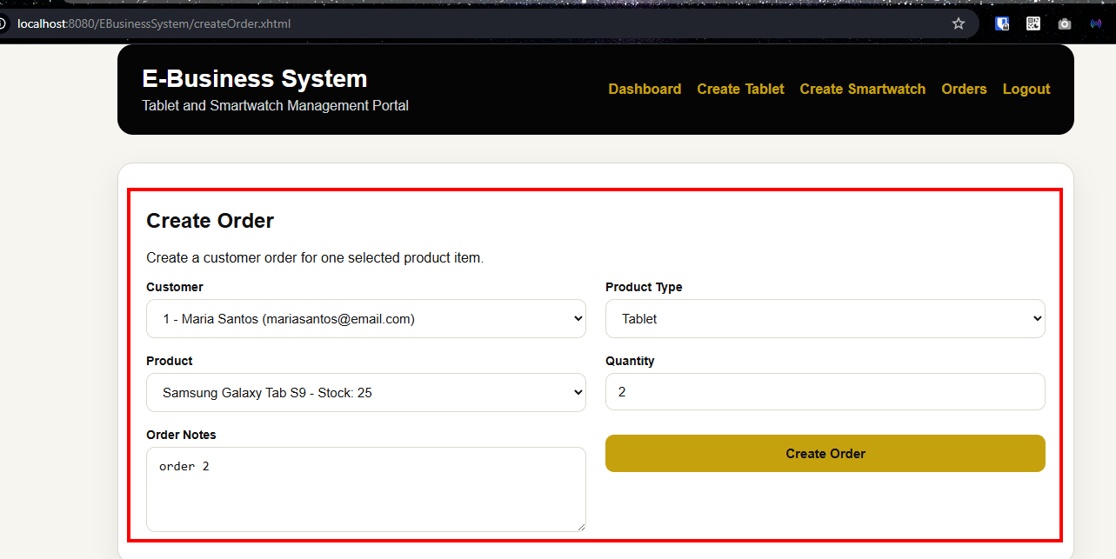

Figure 27. Order list showing the first customer tablet order
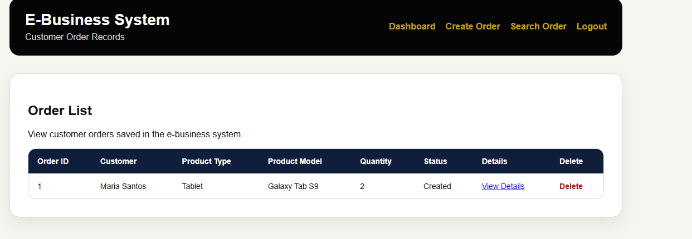

Figure 28. Tablet Stock List After Order
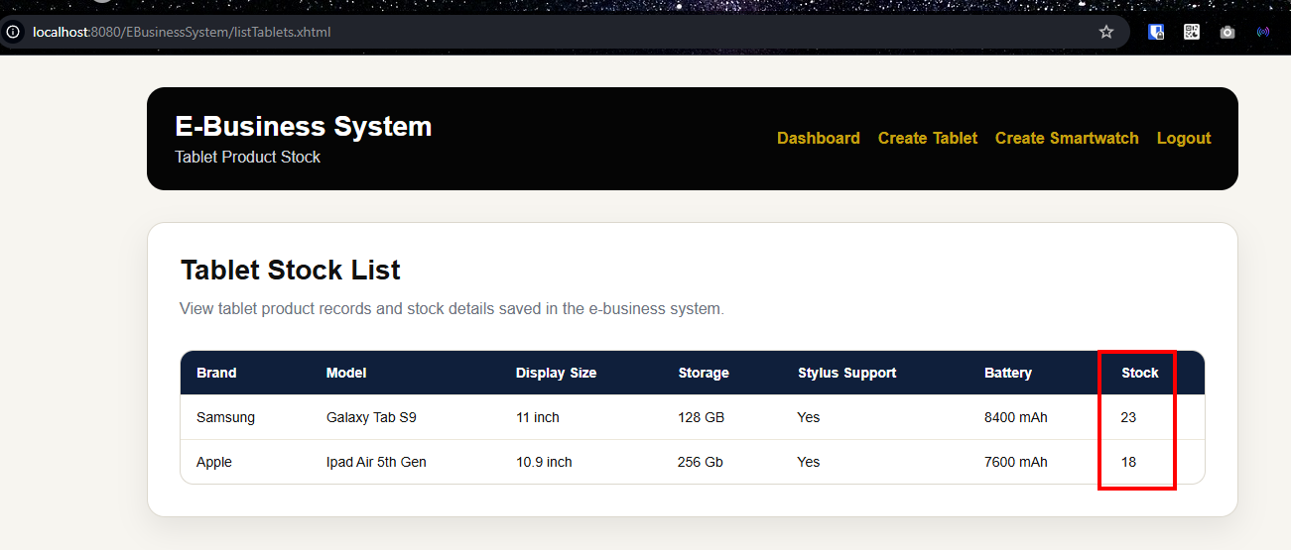

Figure 29. Order list showing the first customer tablet order
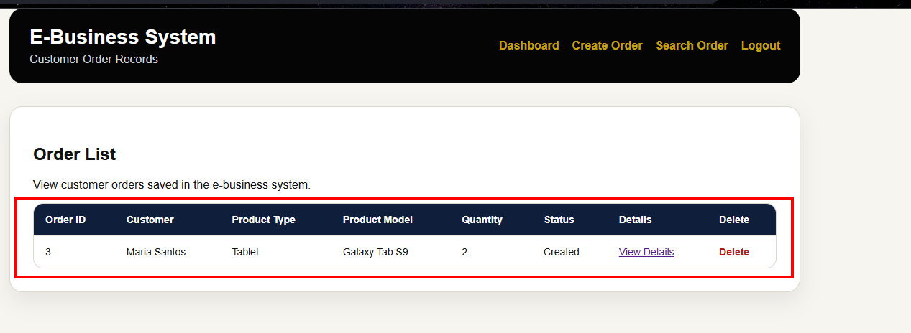

Figure 30. Order Details showing the first customer tablet order
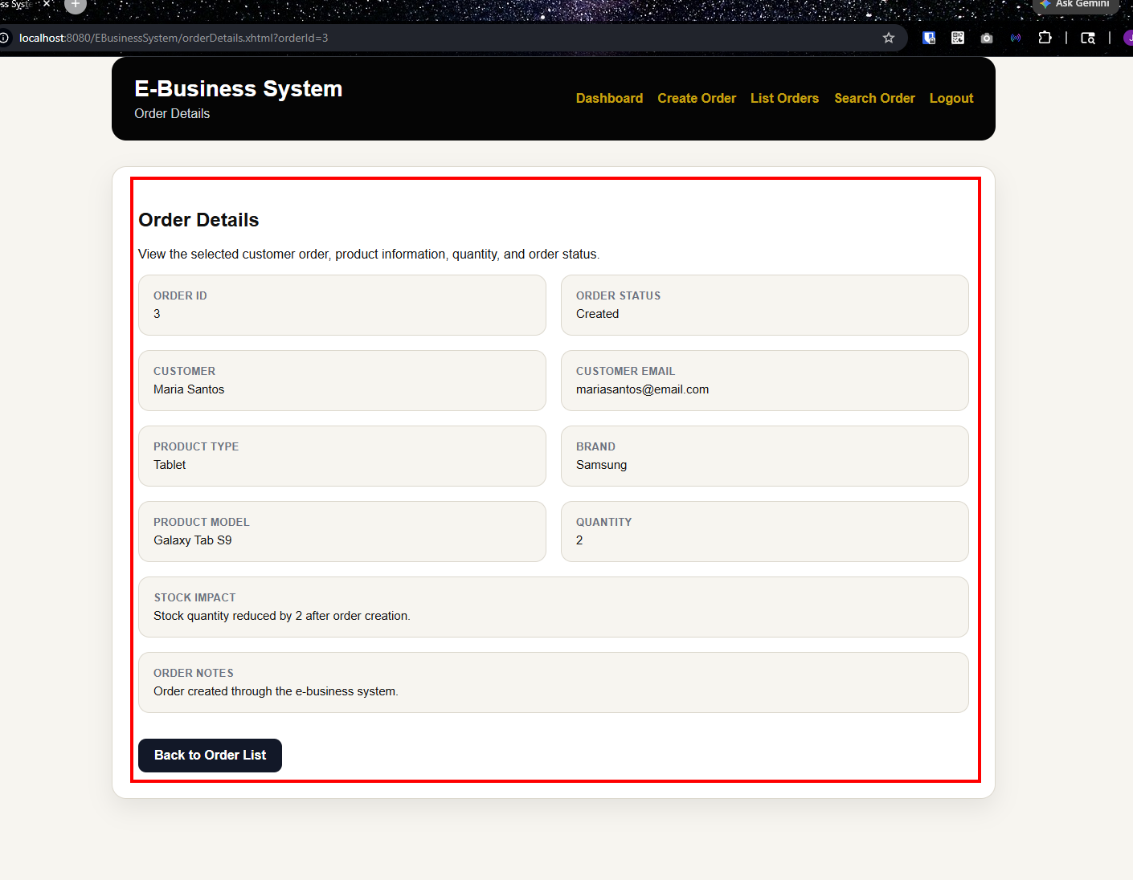

7.2 Creating the Smartwatch Order for the Second Customer

1. Select the option to create or add another order.
2. Select the first customer again.
3. Select a smartwatch product.
4. Enter the order quantity and any other required order details.
5. Click Save or Create.
6. Confirm that the system displays a success message.
7. Open the order list page.
8. Confirm that both orders for the first customer are displayed.

Figure 31. Tablet Stock List Before Order
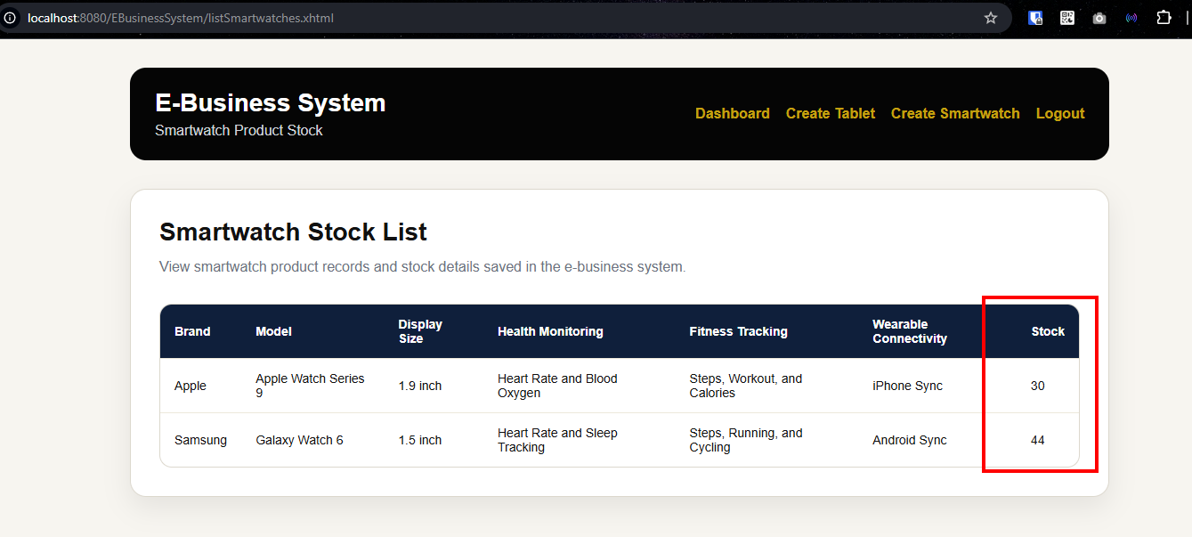

Figure 32. Order creation form completed for the second customer smartwatch order
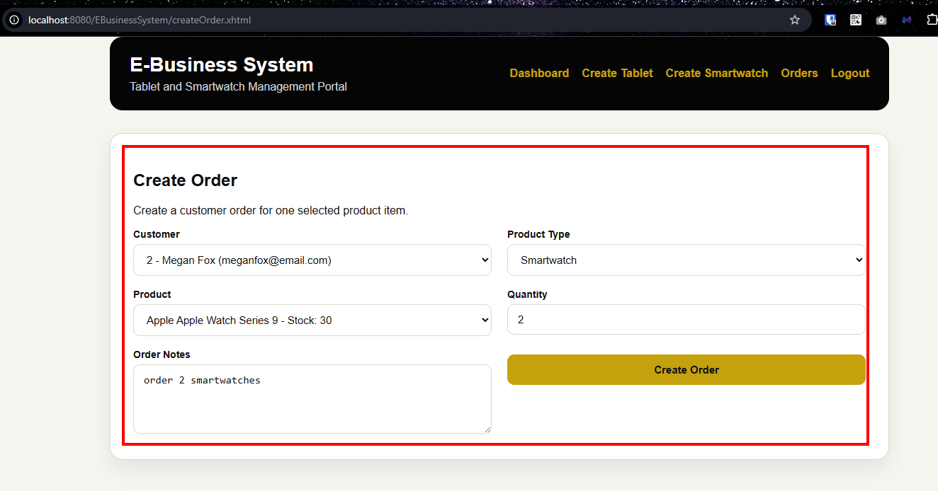

Figure 33. Tablet Stock List After Order
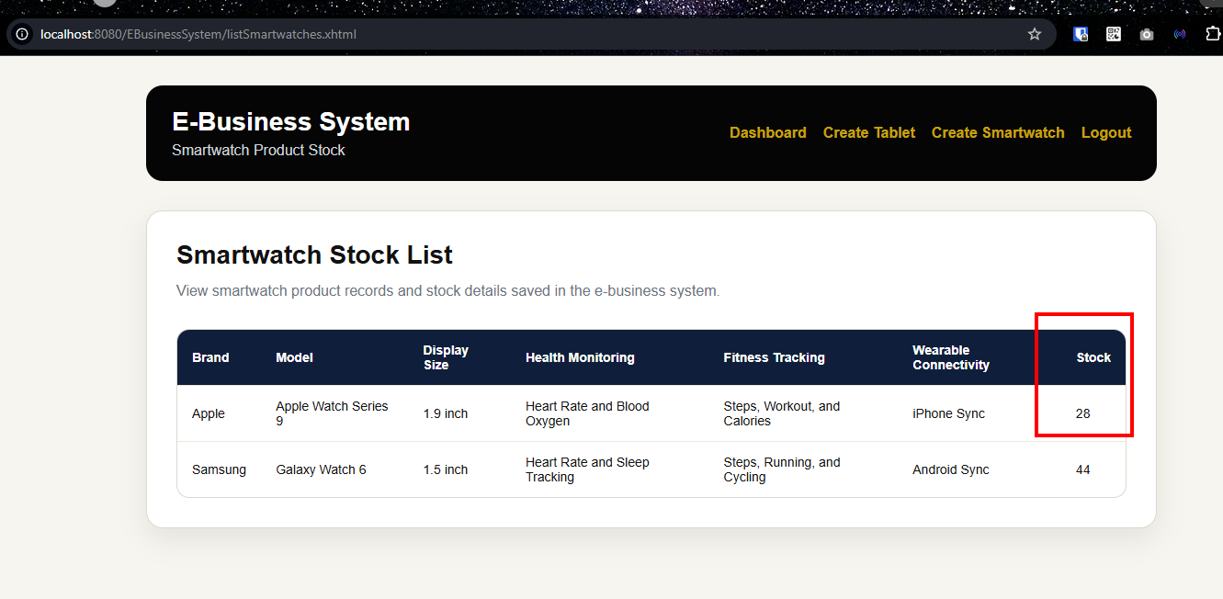

Figure 34. Order list showing the second customer tablet order
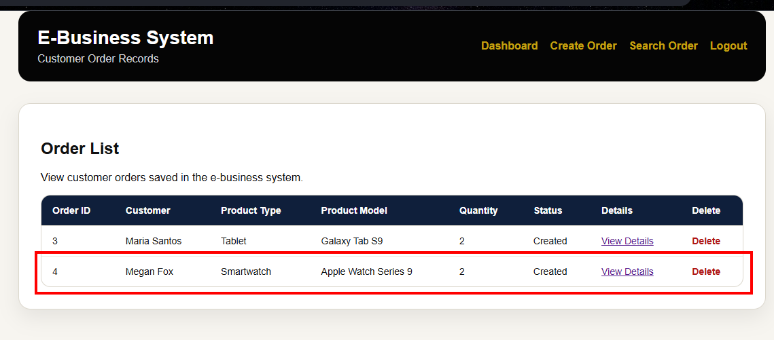

Figure 35. Order Details showing the first customer tablet order
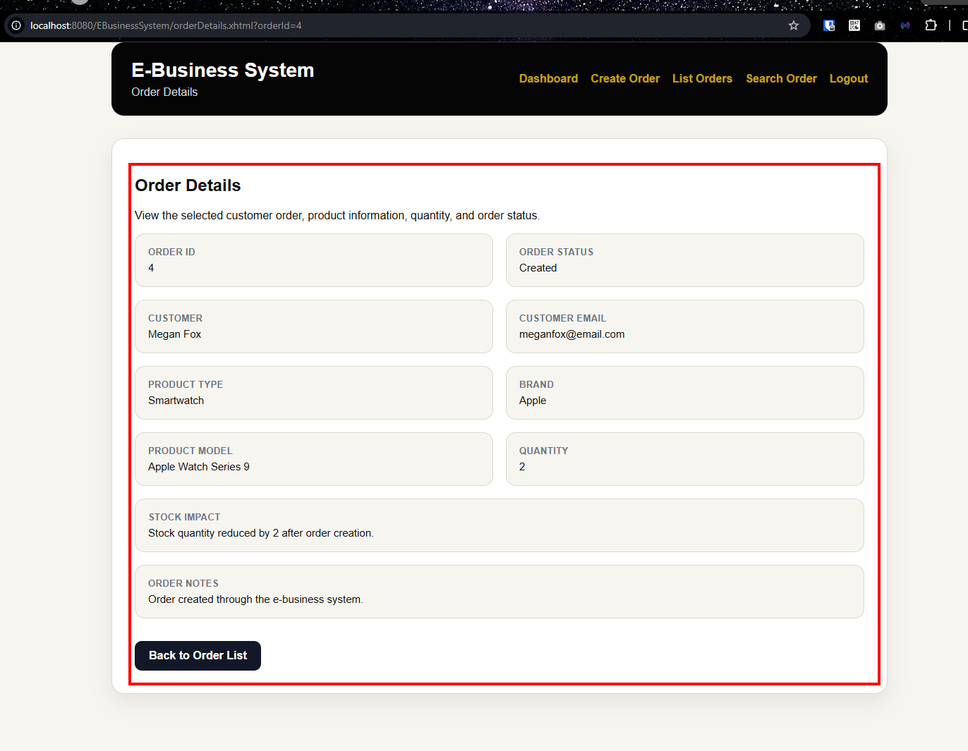

8. Conclusion

This user documentation describes how to compile, deploy, and utilize the e-business system Online Electronics Retail Store. The methods to set up GlassFish, MySQL and FakeSMTP were explained, then the primary user features of the system. These functions are user registration, email verification, login, logout, account recovery, product management, customer management, and order management.
The system was tested with the sample data required such as two tablet records, two smartwatch records, two customer records and order records for each customer. MySQL Workbench was also used to verify that the saved user account, product, customer and order entries were saved in the database.
In general, the final system meets the three-tier architecture of Jakarta EE by linking the presentation

